MEMS microphone design

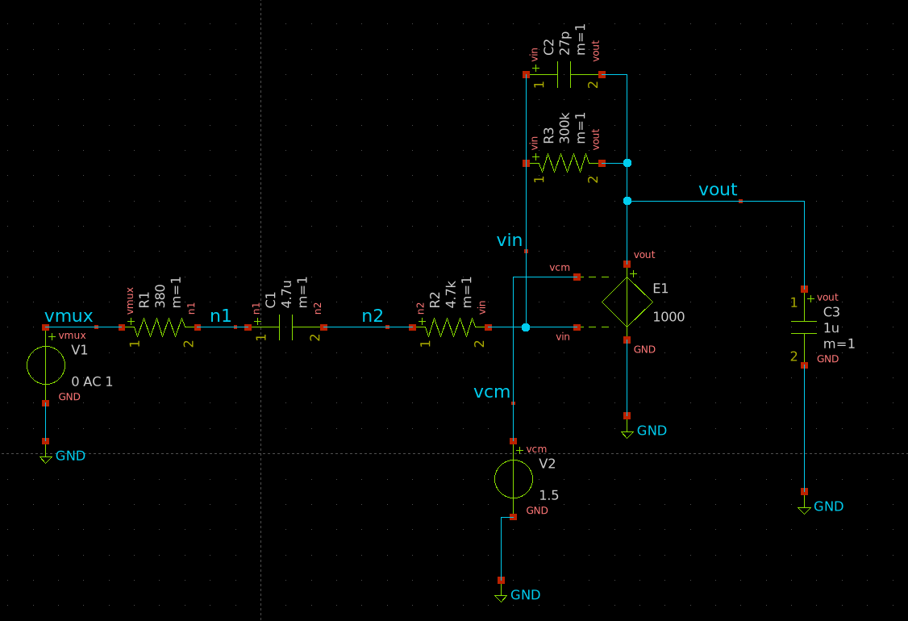

Opam Design for MEMS

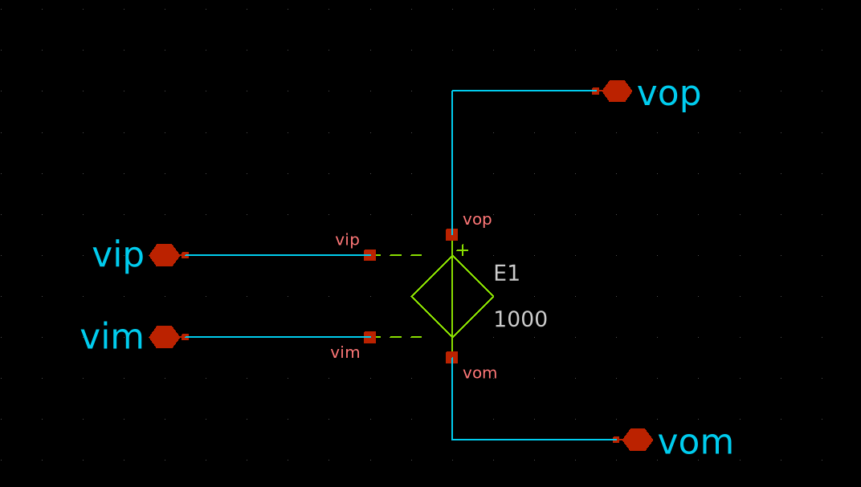

Opam of MEMS

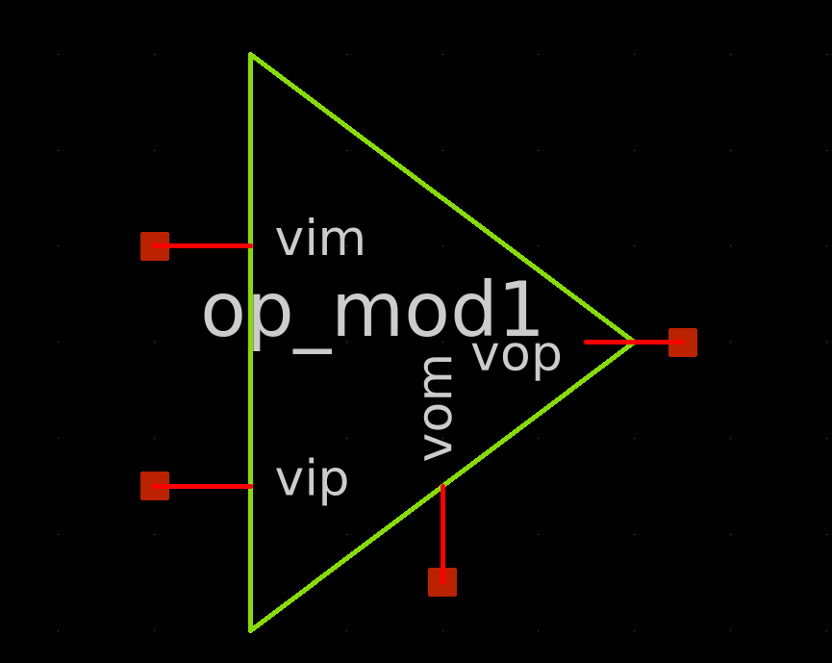

MEMS microphone design with its opam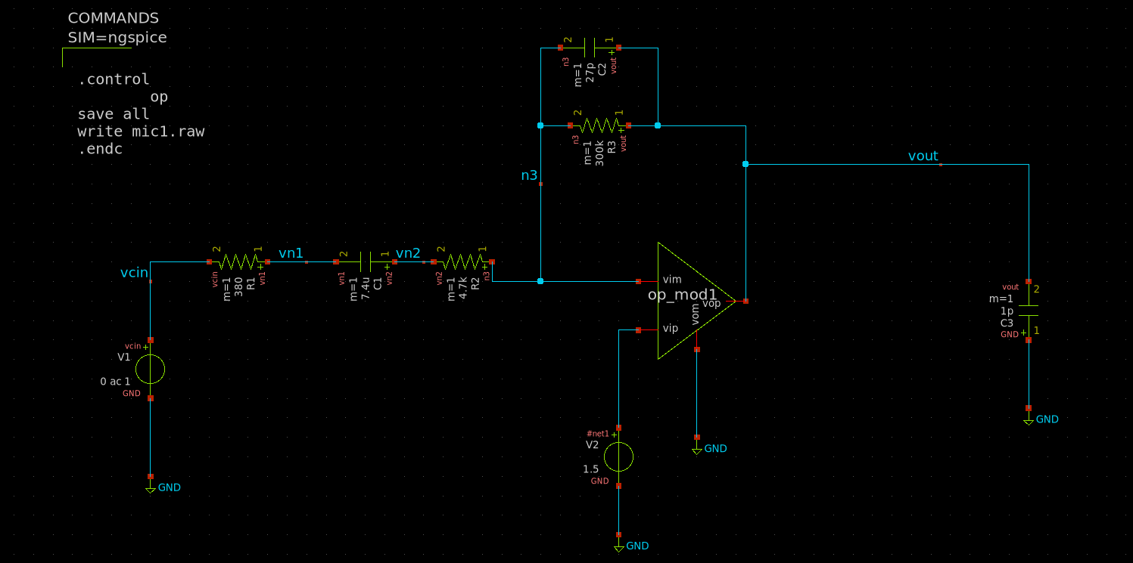

High pass filter circuit with opam

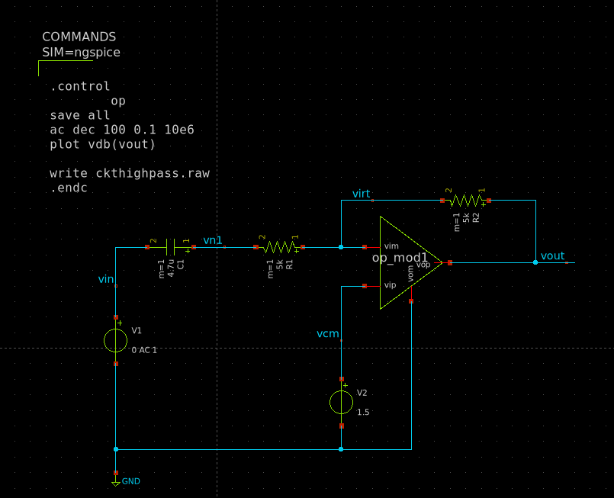

Circuit for a buffer for high pass circuit

Op-am design for a high pass circuit

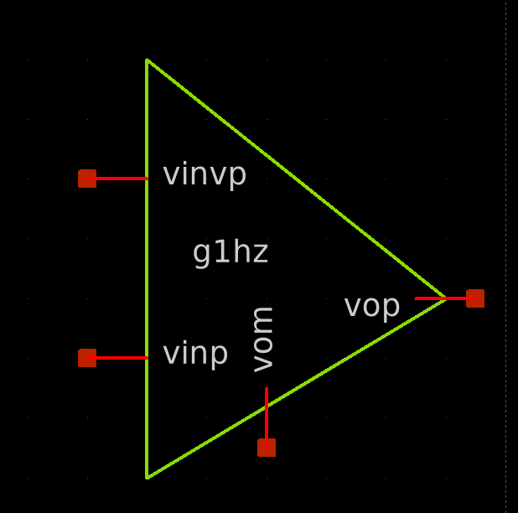

High pass filter with buffer opam

